Please see images below for my project proposal. Objects I will be using in my project will be the iPad, Coca Cola soda can, cat ball toy, and the galaxy desk pad. The desk pad will be a plane for the objects to sit on, the cat ball toy will be a sphere, the iPad will be 2 planes (one plane for the iPad itself and the other for the image of my cat, Luna), and finally the coca cola can will be a cylinder. I think this is manageable and I can import images for the soda can, the ball, desk pad, and iPad.

Front Side:

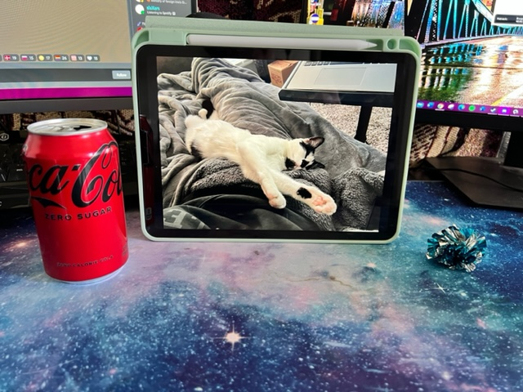

Side View:

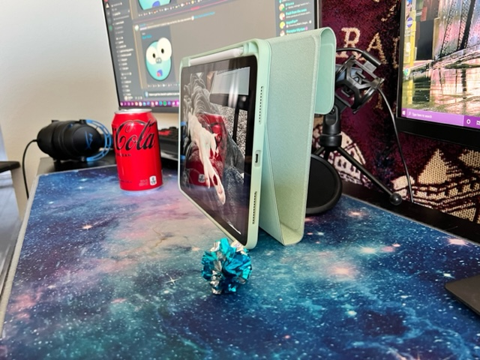

Other side view:

